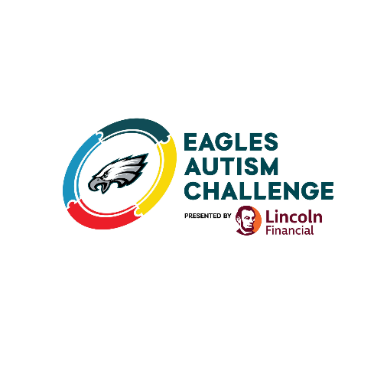

Date

Dear ________________,

The prevalence of autism has increased to 1 in 31 children being diagnosed, making it the fastest growing developmental disorder in our country. Critical research is needed to tackle this complex neurological and developmental condition. The Philadelphia Eagles organization is committed to changing autism awareness into action, and so am I.

On May 9th, I will participate in the Eagles Autism Challenge with Philadelphia Eagles players, coaches, staff and thousands of others. Together, we will walk, run, or ride to raise funds for innovative autism research and care programs. Every dollar donated through Eagles Autism Challenge will be invested at institutions advancing breakthroughs in the field of autism and care programs providing services and support to the community.

(You can insert a personal connection, or story, about why you are participating in the Eagles Autism Challenge here.)

Will you support me by taking action and donating to my fundraising page? (insert link to personal fundraising page). Please know that 100% of your donation funds autism research and care programs that is tax deductible. If you prefer to donate by check, please make your check payable to the Eagles Autism Challenge, include my name in the check memo, and mail to:

Eagles Autism Challenge
ATTN: Makayla Brant
One NovaCare Way
Philadelphia, PA 19145

Thank you very much for your support. Together with the Philadelphia Eagles organization, we are making a transformational impact in the autism community!

Sincerely,

Name

Sample Social Posts

#EaglesAutismChallenge
Facebook/X (Twitter)/Instagram
Posting a photo and adding a personal connection or story always helps!
- Join me and the Philadelphia Eagles in changing the conversation from autism awareness to action! I’ll be participating in the 2026 Eagles Autism Challenge on May 9th. Please consider donating to my fundraiser here (insert link) or join me in walking, running, or riding for this amazing cause. #EaglesAutismChallenge

- 1 in 31 children are diagnosed with autism. I am passionate about making a difference and will be participating in the Eagles Autism Challenge. Please join me making transformational impact in the autism community by donating to my fundraising page (insert link). Every dollar will be invested in autism research and care, any amount helps! #EaglesAutismChallenge

